Southern New Hampshire University
CS 330 Milestone One
Jessica Johnson
07/13/2025
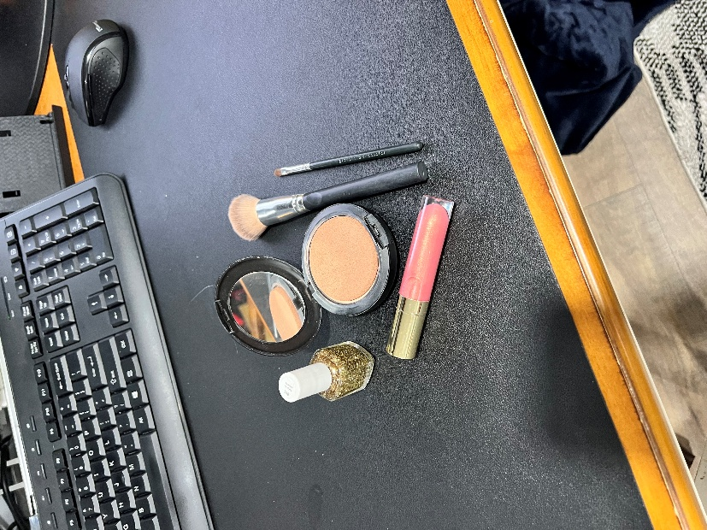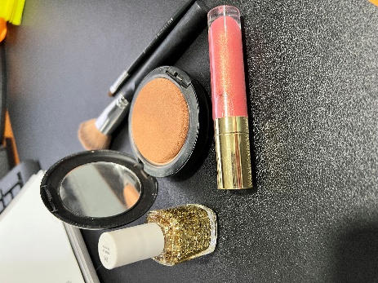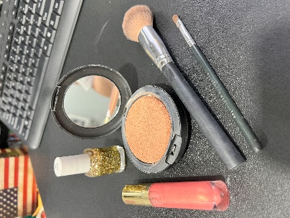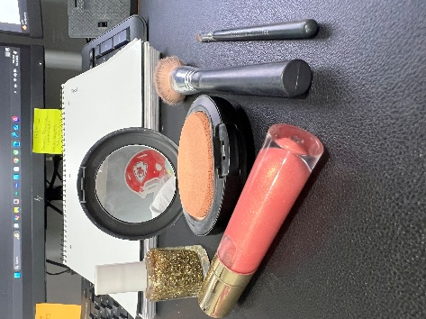

For my milestone project,I have selected 5 cosmetic objects to replicate in 3D. The overall ttheme of the scen is centerd around beauty products. I took the photos myself featuring the following items: glittery nail polish, shimmery lipgloss, an opened mirrored compact, and two different brushes. This setup gives me a variety of textures and shapes to work with as I begin to plan the realistic scene using OpenGl. I found the bristles of the brushes might be a challenge and the shiny surfaces were also a great addition. All the items also sit nicely on the flat plane, the desk.
Which basic shapes will be used for each object?
Compact with Mirror
Cylinder for the base, plane for the mirror surface, another cylinder for the top
Lip Gloss Tube
Cylinder for the body, sphere for the rounded ends, and cone for the detail
Nail Polish Bottle
Tapered cylinder for the bottle, cylinder for the cap, prism for the glitter
Large Brush
Cylinder for the handle, tabpered cylinder for the bristles
Small Brush
Cylinder for the handle, cone for the bristles
Desk Surface
Plane for the surface of the desktop

By using at least four different shapes (cylinder, plane, sphere, and tapered cylinder) I will gain a better understanding of image representation. The plane will serve as the desktop serving as the base for the scene. The goal is to create a realistic 3D space using a collection of simple shapes that are layered and manipulated together.

